**Web engineering Lab # 12**

# Q #1 Write a JavaScript Program to take input range from the user and Guess a Random Number. The program continues until the user guess the number.

# 

# There are three levels and must select at least any one option.

# Basic Level Range 1 t0 10

# Intermediate Level range 50 to 100

# Advance level Range 101 to 500

# Note: After selecting an option, the user can enter numbers only within the number range of that option.

## **Q #2** Write a JavaScript Program to take inputs natural numbers from the user to find the sum of natural numbers and displays a sum of value on the screen.

# 

* Check empty fields without required attribute and show error message in front of text box
* Set placeholder in text boxes.
* Create two buttons and apply appropriate Tailwind CSS.

## **Q #3** Write a JavaScript Program to get the number from the user and Check Armstrong Number or not and displays a message on the screen.

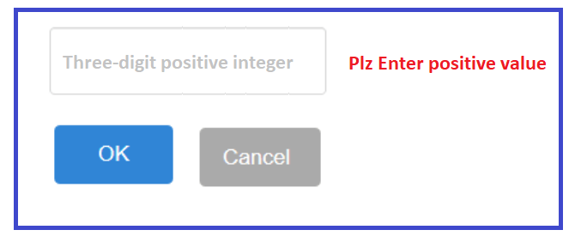

* Check empty fields without required attribute and show error message in front of text box
* Set placeholder in text boxes and accept only three digit values
* Create two buttons and apply appropriate Tailwind CSS.

# Q #4 Write a JavaScript Program to convert decimal to binary and hexadecimal value and displays a message on the screen.

# 

# There are two options and must select at least any one option.

* Create two buttons and apply appropriate Tailwind CSS.

## **Q #5** Write a JavaScript Program to take input from the user and convert value into different temperature and show result as alert on the screen.

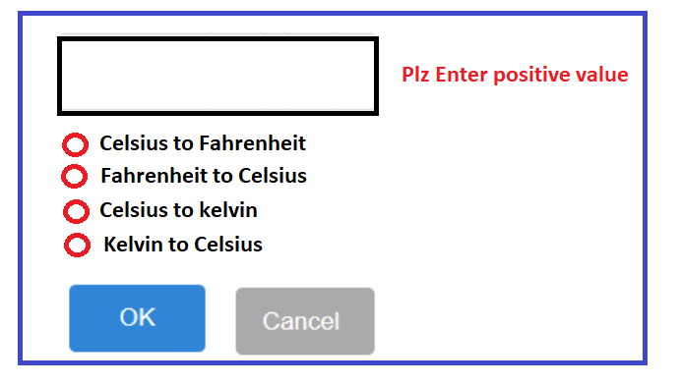

# There are four options and must select at least any one option.

**Formulas:**

* Celsius to Kelvin: K = C + 273.15
* Kelvin to Celsius: C = K - 273.15
* Fahrenheit to Celsius: C = (F-32) (5/9)
* Celsius to Fahrenheit: F = C(9/5) + 32